Software Requirements Specification Calendar Management



**Record of change**

*A - Added M - Modified D - Deleted

|  |  |  |  |  |
| --- | --- | --- | --- | --- |
| Effective Date | Changed Items | A* M, D | Change Description | New Version |
| Nov 25, 2019 |  | A | Create SRS Document | 1.0 |
| Nov 27, 2019 | Use case | M | Add UC02, UC03, UC04, UC05, UC06, UC07 | 1.1 |
| Dec 06, 2019 | Use case | A | Add UC08 | 1.2 |
| Dec 06, 2019 | Use case | M | UC07: Create dayoff to delete calendar | 1.2 |
| Dec 06, 2019 | Mockup Screens | A | Login, Register | 1.2 |
| Dec 06, 2019 | Mockup Screens | D | Create dayoff | 1.2 |
| Dec 08, 2019 | Mockup Screens | A | Create calendar, Delete calendar | 1.3 |
| Dec 08, 2019 | Mockup Screens | M | Create date, Delete date | 1.3 |
| Feb 21, 2019 | Mockup Screens | M | Create calendar can also add a trainer | 1.5 |
| Feb 21, 2019 | Mockup Screens | A | Edit Calendar can also Add trainer to it | 1.5 |
| Feb 21, 2019 | Mockup Screens | A | Show trainee list of calendar | 1.5 |
| Feb 21, 2019 | Mockup Screens | A | Add trainee to calendar | 1.5 |
| Feb 21, 2019 | Mockup Screens | A | Show and Edit user’s information | 1.5 |
|  |  |  |  |  |
|  |  |  |  |  |
|  |  |  |  |  |
|  |  |  |  |  |
|  |  |  |  |  |
|  |  |  |  |  |
|  |  |  |  |  |
|  |  |  |  |  |
|  |  |  |  |  |
|  |  |  |  |  |

**SIGNATURE PAGE**

**SIGNATURE PAGE**

**ORIGINATOR:** <Name> SangTM6 <Date>25th – 25th Nov, 2019

<Position> Team

**REVIEWERS:**

**APPROVAL:**

Contents

 2

**Record of change** 2

**SIGNATURE PAGE** 3

2. Introduction 5

2.1. Purpose 5

2.2. Definitions, Acronyms, and Abbreviations 5

2.3. References 5

3. High Level Requirements 6

3.1. Product Perspective 6

3.2. Actors and Use Cases Descriptions 6

3.2.1. Diagram 6

3.2.2. Actors Description 6

3.2.3. Use Cases Description 6

3.2.4. Use Case & Actor mapping 7

3.3. Operating Environment 7

3.4. Assumption and Dependencies 7

4. Functional Requirements 7

4.1. User 7

4.1.1. Login 7

4.1.2. Register 9

4.1.3. Dashboard 11

4.1.4. Calendar Manager 12

4.1.5. Create calendar 13

4.1.6. Delete calendar 14

4.1.7. Load calendar 15

4.1.8. Edit exist day 16

4.1.9. Delete day 17

5 Non-Function Requirements 17

6 Mockup Screens 18

6.1 SC01: User home page 18

6.2 SC02: Calendar Manager 18

6.3 SC03: Edit date 19

6.4 SC04: Delete date 20

6.5 SC05: Login page 21

6.6 SC06: Register page 21

6.7 SC07 Create calendar 22

6.8 SC07 Delete calendar 23

# Introduction

## Purpose

SRS Calendar Management is the complete and comprehensive description of software requirement. This document describes external behaviour as well as non-functional requirements of Calendar Management project. It will be the basic for further analysis and design model.

## Definitions, Acronyms, and Abbreviations

|  |  |  |
| --- | --- | --- |
| **#** | **Abbreviations/Terms** | **Explanation** |
| 1 | SRS | Software Requirement Specification |
| 2 | SC | Screen |
| 3 | UC | Use Case |

Table 1: Abbreviations & Terminologies

## References

|  |  |  |
| --- | --- | --- |
| **#** | **Name** | **Description** |
|  |  |  |

Table 2: Reference

# High Level Requirements

## Product Perspective



This website help user manage working days and day off.

## Actors and Use Cases Descriptions



### Diagram

**Diagram 01 – Calendar Management**

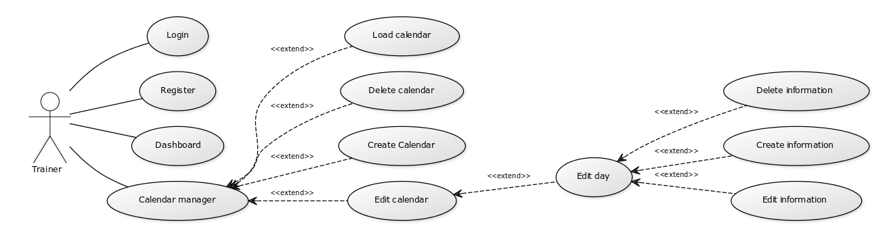

### Actors Description

|  |  |  |
| --- | --- | --- |
| **#** | **Actor Name** | **Definition & Interests** |
| **1** | Trainer |  |

### Use Cases Description

|  |  |  |  |
| --- | --- | --- | --- |
| **#** | **Code** | **Name** | **Brief Description** |
| Home Page | | | |
| 1 | UC01 | Login | Allow user login |
| 2 | UC02 | Register | Allow user register |
| 3 | UC03 | Dashboard | Show home page for user after login |
| 4 | UC04 | Calendar Manager | User can manager their own calendar |
| 5 | UC05 | Create calendar | Allow user create new calendar |
| 6 | UC06 | Delete calendar | Delete exist calendar |
| 7 | UC07 | Load calendar | Load default calendar |
| 8 | UC08 | Edit exist date | Allow user edit exist |
| 9 | UC09 | Delete day | Allow user delete exist day |

Table 3: Use Case List

### Use Case & Actor mapping

|  |  |
| --- | --- |
| **Actor**  **Use Case** | **Trainer** |
| UC01: Login | **x** |
| UC02: Register | **x** |
| UC03: Dashboard | **x** |
| UC04: Calendar Manager | **x** |
| UC05: Create calendar | **x** |
| UC06: Delete calendar | **x** |
| UC07: Load calendar | **x** |
| UC08: Edit exist day | **x** |
| UC09: Delete day | **x** |

## Operating Environment

* Windows 10
* ASP.Net 4.5

## Assumption and Dependencies

# Functional Requirements

## User

Manipulation

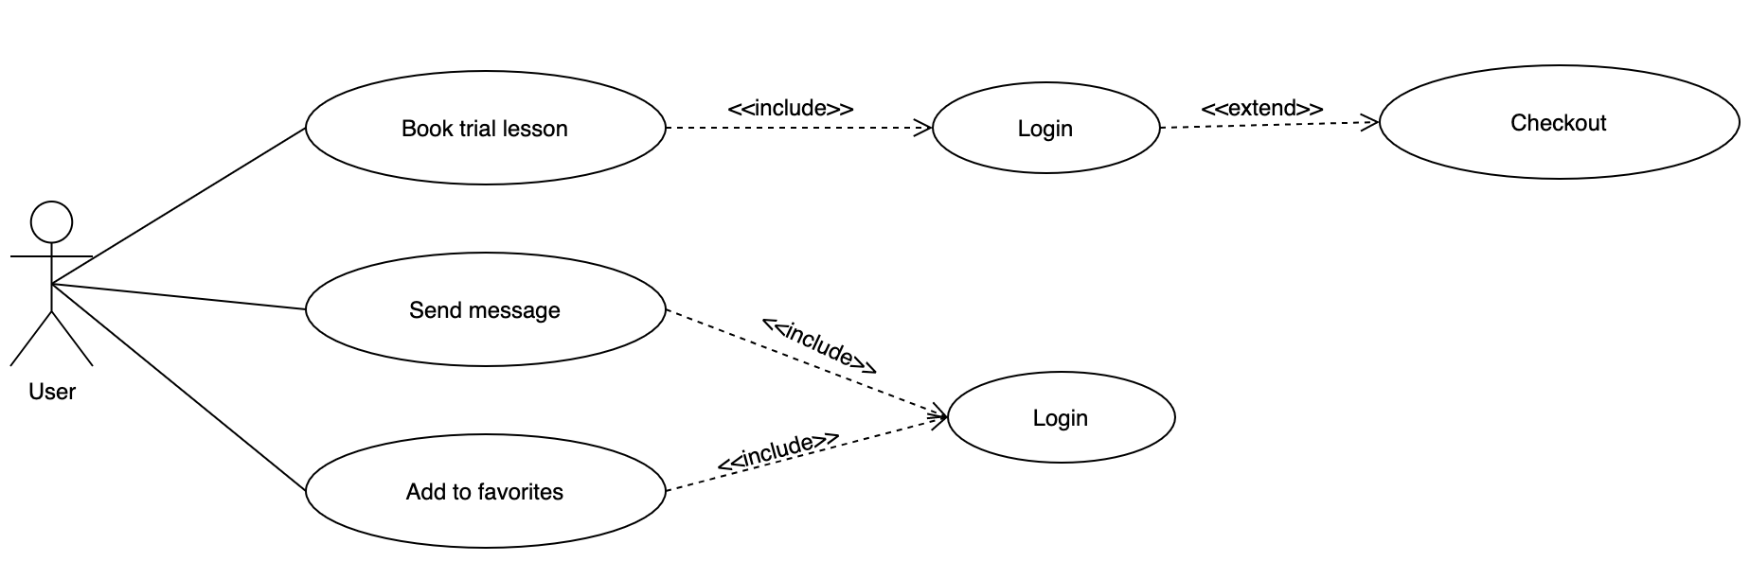

**Use Case Description**

|  |  |  |  |
| --- | --- | --- | --- |
| **Name** |  | **Code** |  |
| **Description** | Allow user login or register | | |
| **Actor** | User | **Trigger** | - after user log in  Click book lesson, send message, add to favorites |
| **Pre-condition** | User logged in | | |
| **Post condition** |  | | |

**Activities**

|  |  |  |  |
| --- | --- | --- | --- |
| **User** | | **System** | |
| **Main Flow: Book is successful** | | | |
|  |  | **1** |  |
| 2 |  |  |  |
| 3 | User click book button |  |  |
|  |  | **4** |  |
|  |  | **5** |  |

**Business Rules**

|  |  |  |
| --- | --- | --- |
| **Rule No.** | **Rule** | **Description** |
| 1 | Login | * The operation of the tutor details page must be logged in |

**System Message**

|  |  |
| --- | --- |
| Login | When checkout, send message, and add to favorites, it will direct to the login page. |
| Book trial lesson | When you click on the book trial lesson without choosing a time and click Proceed, there will be a notice this field is required. |

# Non-Function Requirements

* Website is simple interface.
* Website is easy to use.
* Database: SQL Server

# Mockup Screens

## SC01: Tutor details page

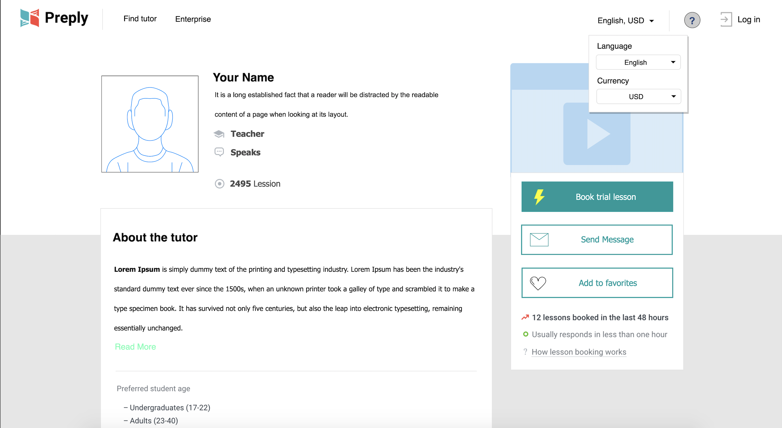

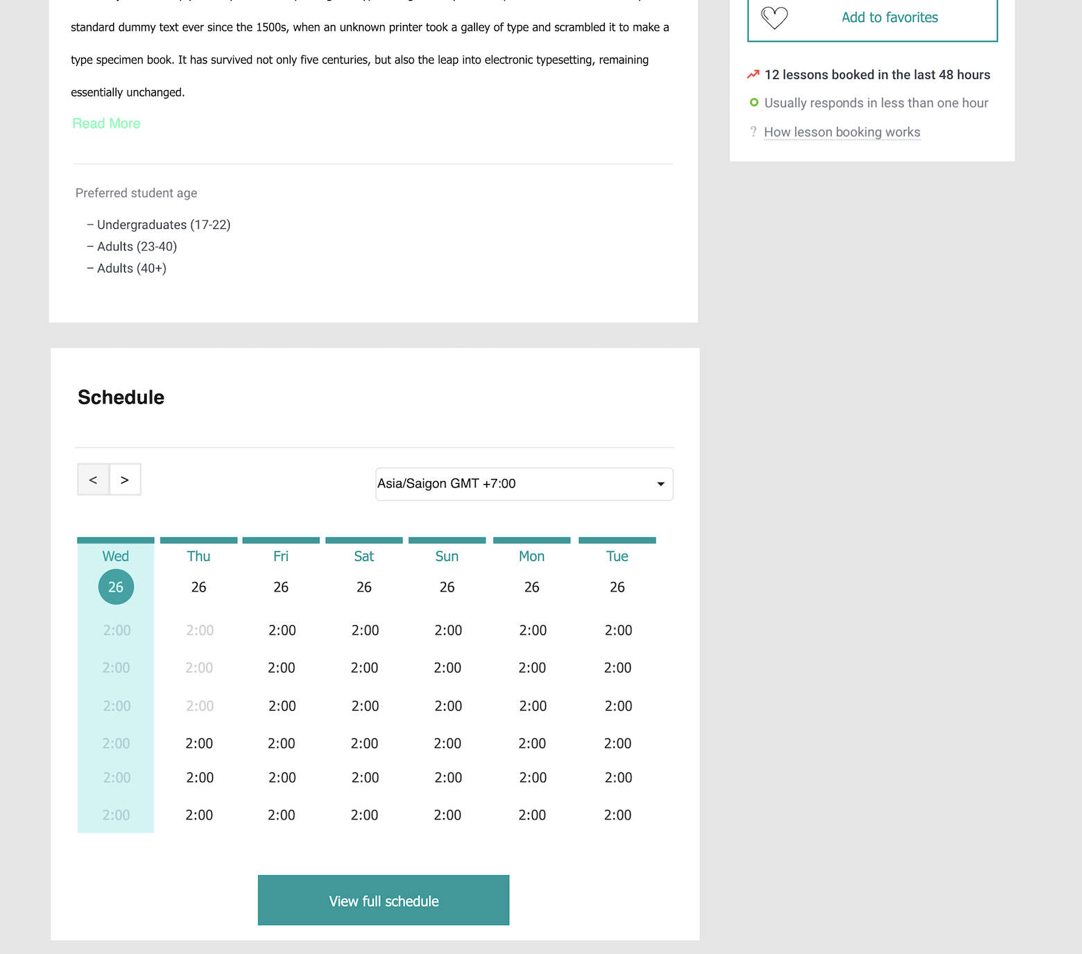

**Data field**

|  |  |  |  |
| --- | --- | --- | --- |
| No | Item | Type | Description |
| 1 | Book trial lesson | Button | Order lesson |
| 2 | Send Message | Button | Send a message to the teacher |
| 3 | Add to favorites | Button | Save instructors to favorites |
| 4 | Click hour | Button | Choose a time to schedule lessons |

## SC02: Book trial lesson

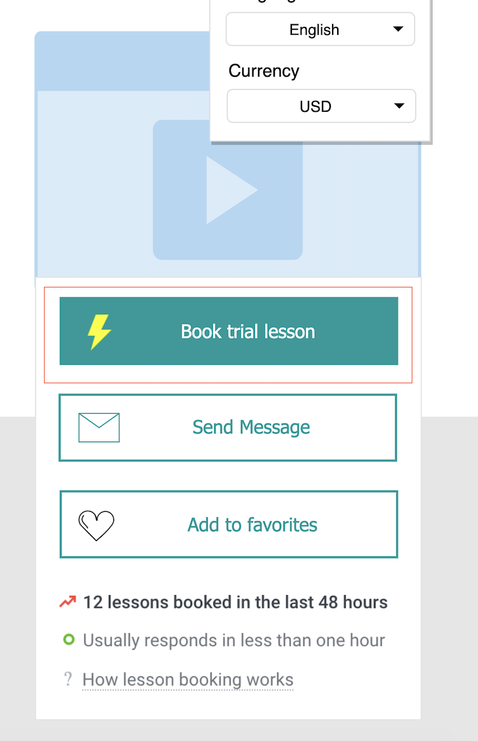

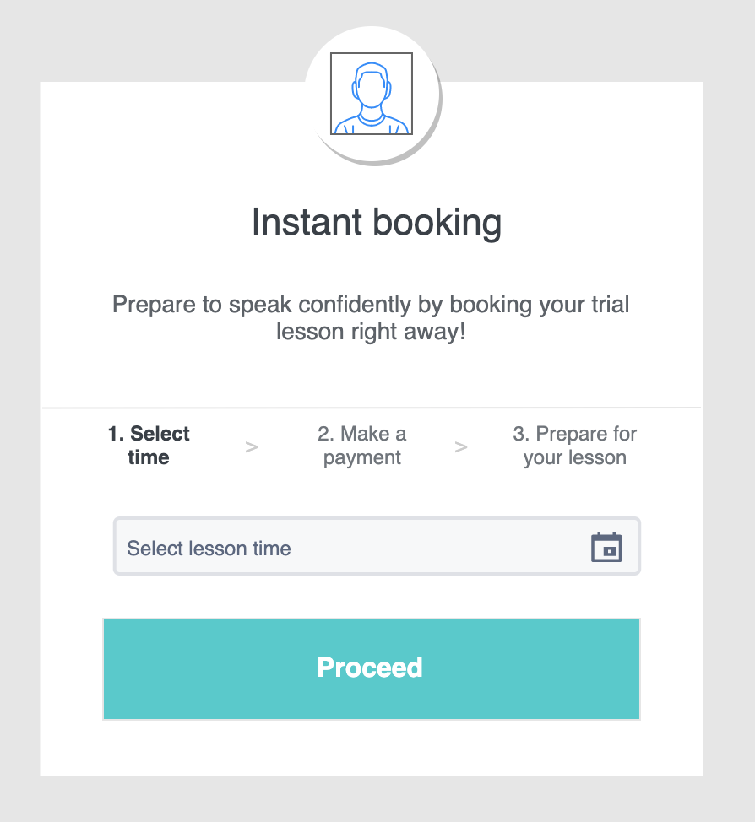

**Data field**

|  |  |  |  |
| --- | --- | --- | --- |
| No | Item | Type | Description |
| 1 | Book trial lesson | Button | Order lesson |
| 2 | Select lesson time | Dropdown | Choose a time to schedule lessons |
| 3 | Proceed | Button | Continue to the checkout process |

## SC03: Send Message

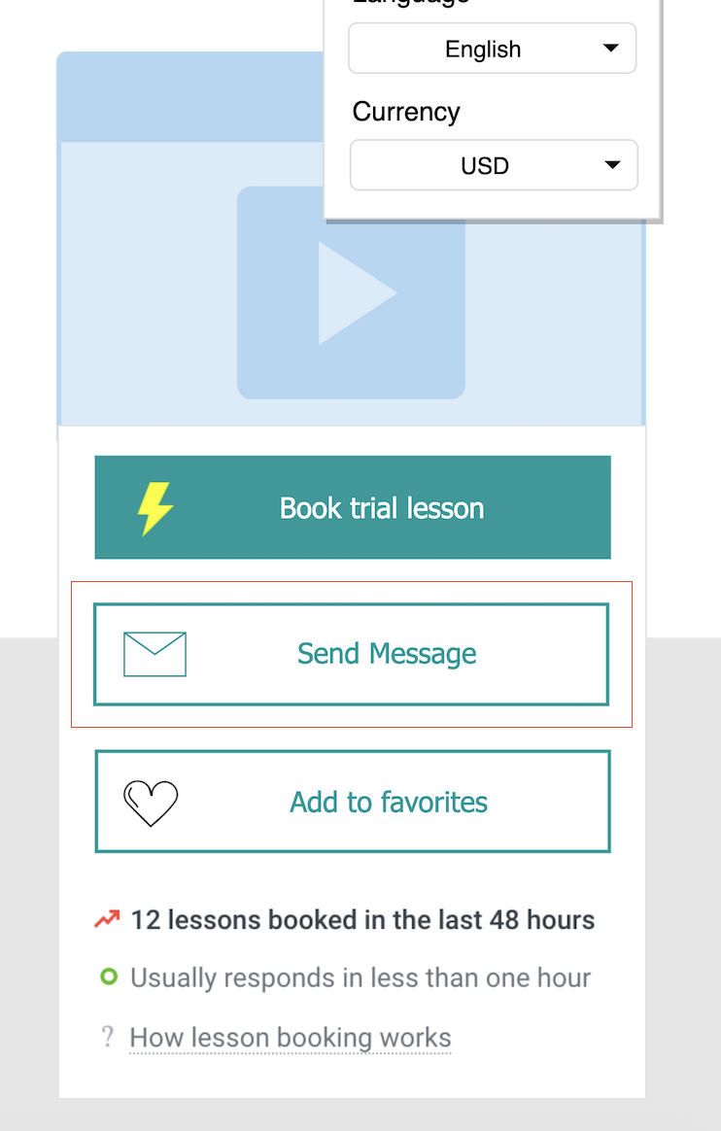

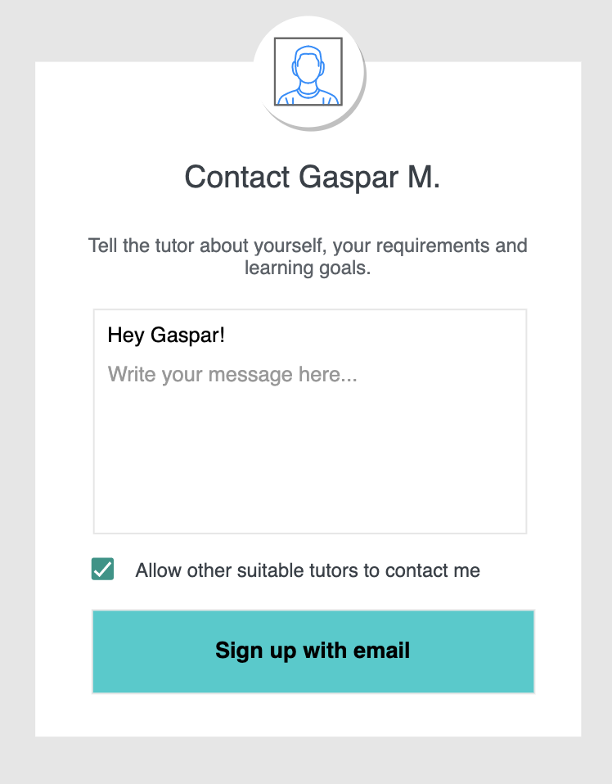

**Data field**

|  |  |  |  |
| --- | --- | --- | --- |
| No | Item | Type | Description |
| 1 | Send Message | Button | Send a message to the teacher |
| 2 | Write your message | Textarea | Enter the information you want to send to that teacher |
| 3 | Allow other … | Checkbox | Allow other suitable tutors to contact me |
| 4 | Sign up with email | Button | Register an account to send messages by email. |